DATA ANALYTICS WITH TABLEAU

ASSIGNMENT-1

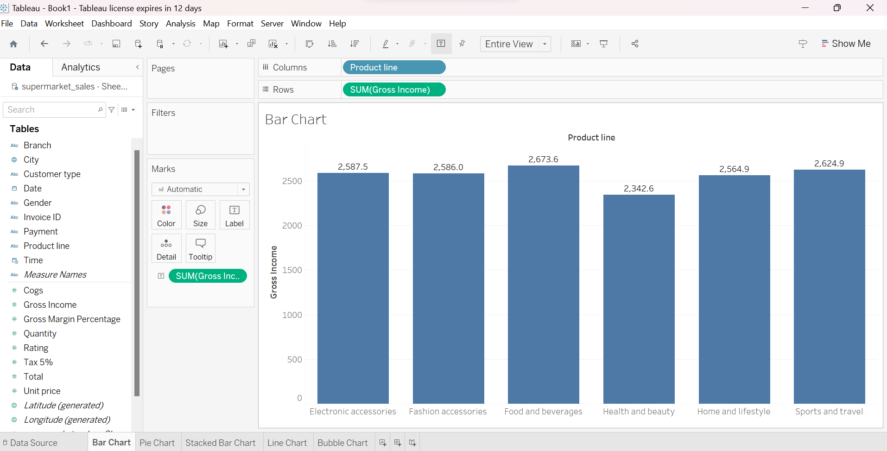1.BAR CHART

2.PIE CHART

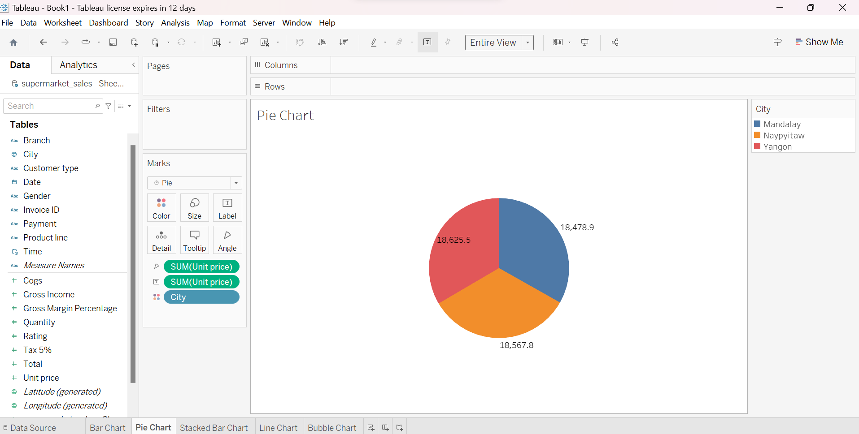

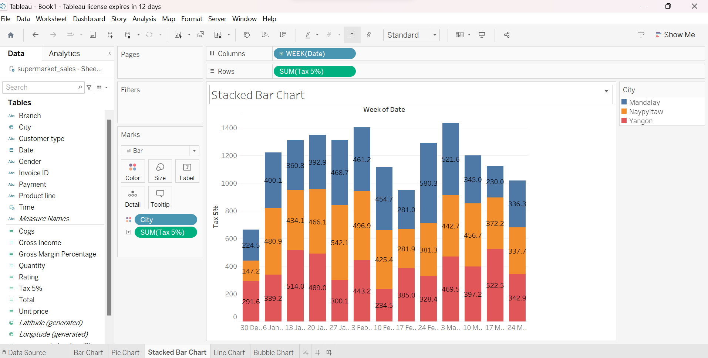3.STACKED BAR CHART

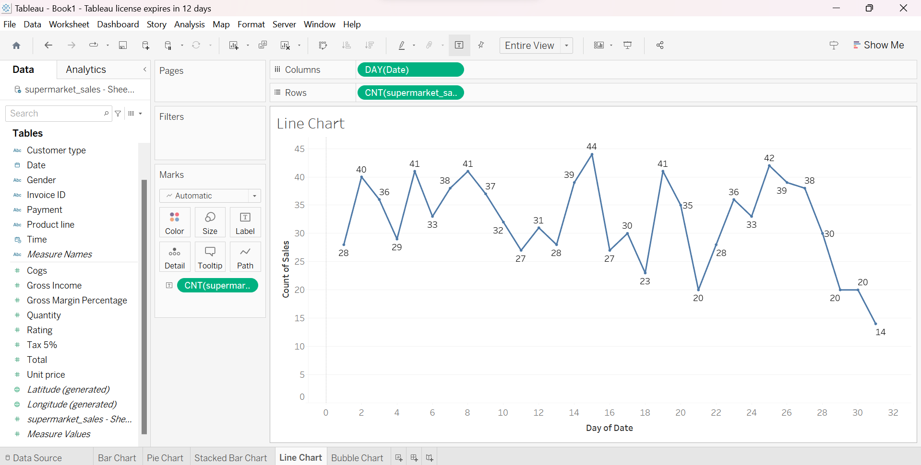4.LINE CHART

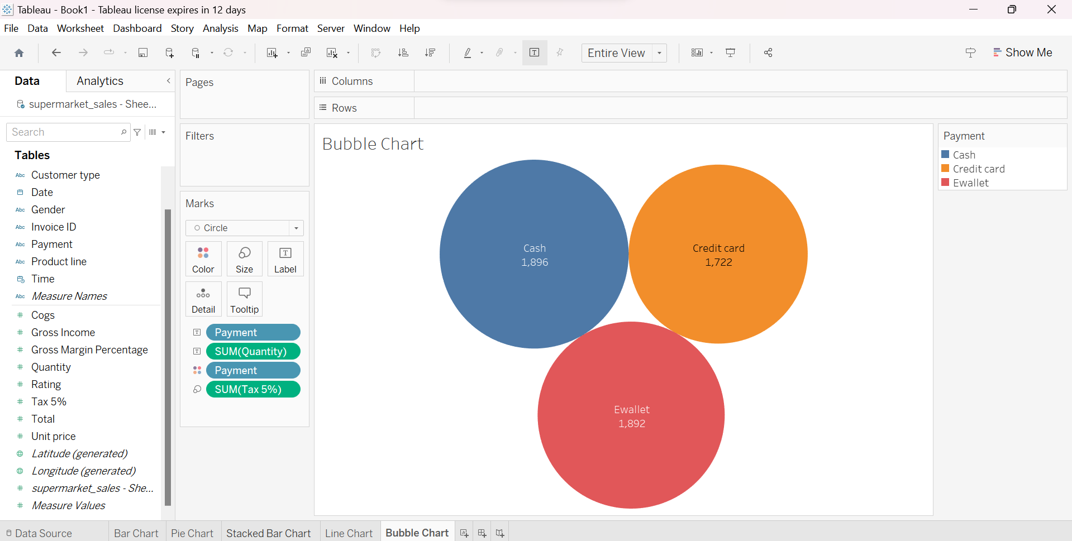5.BUBBLE CHART